Blog: Creating a New Blog Post
Blogs help you drive traffic to your website, be better seen by search engines like Google & Bing, build your brand, and develop better customer relationships. Blogs help you connect directly with your sphere of influence.

Follow the steps below to learn how to add a new post.

- Access Blog Posts in the left panel on the Admin Home screen (see below).
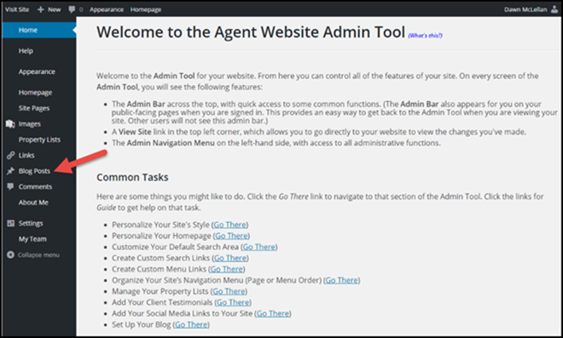
- Select Add New button to create a new blog post (see below).
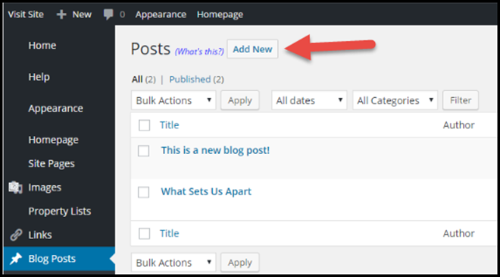
- Add the various elements of your blog post (see below).
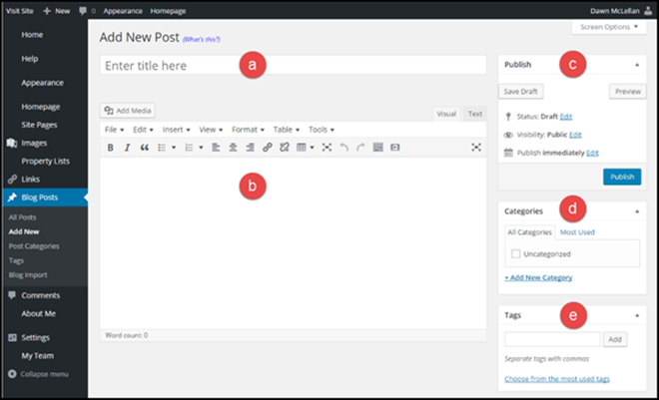
  - Give your post a title.
  - Add your content. You can use the available tools to add media, insert links and line breaks, etc.
  - You can adjust the status of your post, who can view it (visibility), and when the post will publish.
  - Select your categories. Categories determine if your post will be visible from the homepage or another blog post page on your website.
  - Add tags to your post to make searching for it easier.
- Select the Publish button (see below).
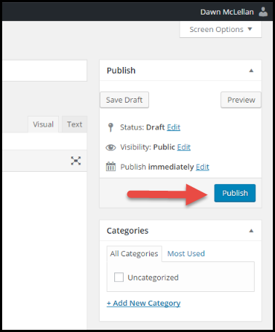
- Press Visit Site
- Navigate to your blog
